**Importing Library in python**

# Import module in Python

Import in python is similar to #include header_file in C/C++. Python modules can get access to code from another module by importing the file/function using import. The import statement is the most common way of invoking the import machinery, but it is not the only way.

**import module_name**  
When import is used, it searches for the module initially in the local scope by calling __import__() function. The value returned by the function are then reflected in the output of the initial code.

|  |  |  |
| --- | --- | --- |
| **import math**  **print(math.pi)**  **import module_name.member_name**  In the above code module math is imported, and its variables can be accessed by considering it to be a class and pi as its object. The value of pi is returned by __import__(). pi as whole can be imported into our intial code, rather than importing the whole module.   |  | | --- | | **from math import pi**    **# Note that in the above example,**  **# we used math.pi. Here we have used**  **# pi directly.**  **print(pi)** |   Output:  3.141592653589793    **from module_name import \*** In the above code module math is not imported, rather just pi has been imported as a variable. All the functions and constants can be imported using *.   |  | | --- | | from math import *  print(pi)  print(factorial(6)) |   Output:  3.141592653589793 |

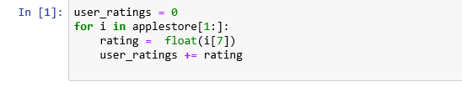

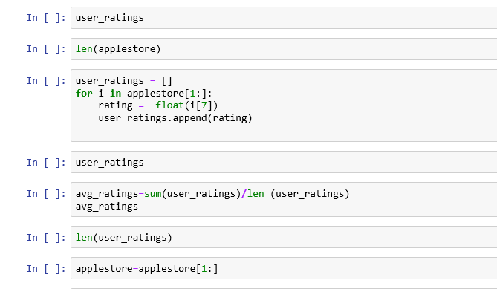

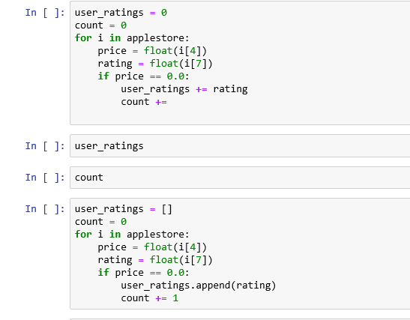

# Working with csv files in Python

**First of all, what is a CSV ?  
CSV** (Comma Separated Values) is a simple **file** **format** used to store tabular data, such as a spreadsheet or database. A CSV file stores tabular data (numbers and text) in plain text. Each line of the file is a data record. Each record consists of one or more fields, separated by commas. The use of the comma as a field separator is the source of the name for this file format.

For working CSV files in python, there is an inbuilt module called [**csv**](https://docs.python.org/2/library/csv.html).

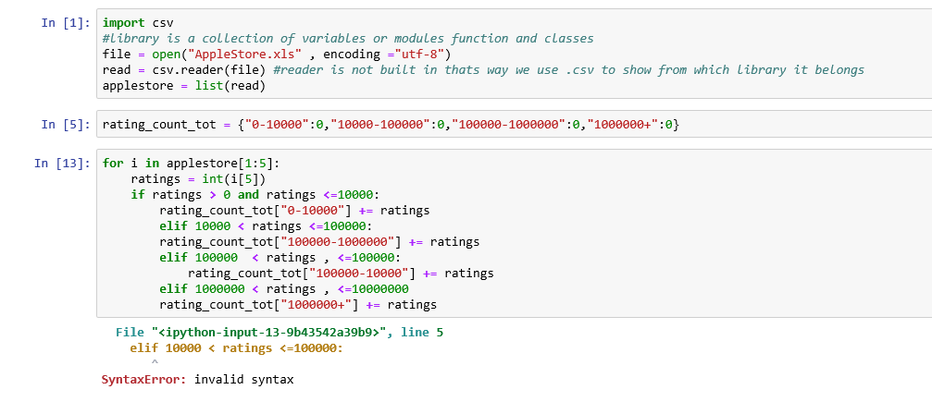

**TASK:**

Using csv file import the given data.

**TASK:**

Show how to input different libraries has come needs.